# COS20015 Fundamentals of Data Management

## Workshop 3 & 4 completed tasks

Alex Vrsecky (104268899)

### Workshop 3

**Part 1**

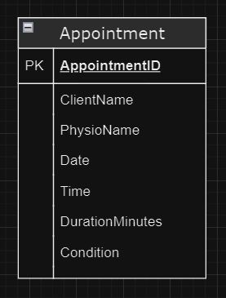

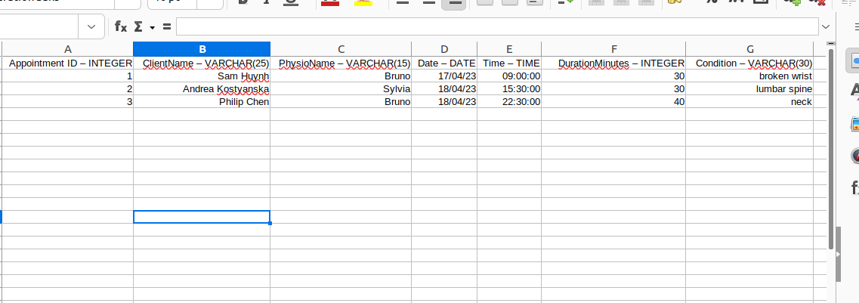

**Part 2**

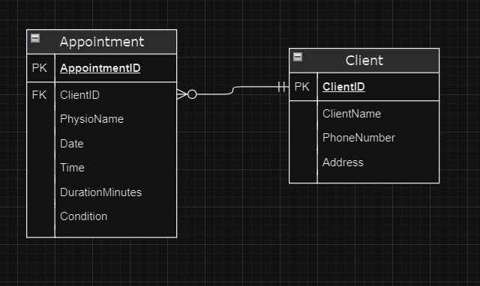

### Workshop 4

**Part 1:**

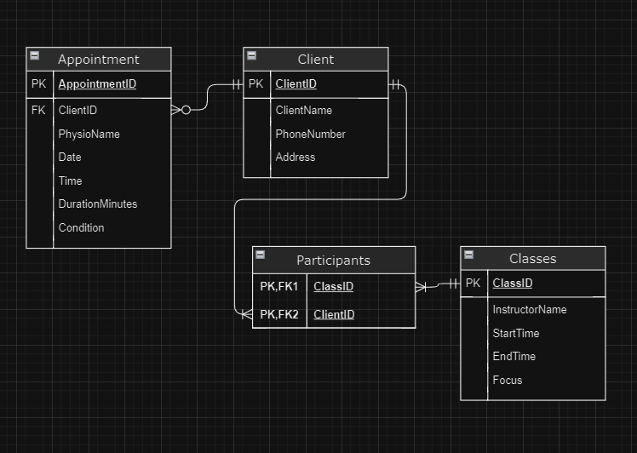

**Part 2:**

|  |  |  |  |
| --- | --- | --- | --- |
| **ClientDetails** |  |  |  |
| ClientID (PK) | ClientName | PhoneNumber | Address |
| 1 | Alice Smith | 401234567 | 12 Elm Street |
| 2 | Bob Johnson | 409876543 | 34 Oak Avenue |
| 3 | Cathy Brown | 412345678 | 56 Maple Drive |

|  |  |
| --- | --- |
| **Participants** |  |
| ClassID (PK, FK) | ClientID (PK, FK) |
| 101 | 1 |
| 101 | 2 |
| 102 | 1 |
| 102 | 3 |
| 103 | 2 |

|  |  |  |  |  |
| --- | --- | --- | --- | --- |
| **Classes** |  |  |  |  |
| ClassID (PK) | InstructorName | StartTime | EndTime | Focus |
| 101 | Bruno | 10:00 AM | 11:00 AM | Spine |
| 102 | Deepika | 11:30 AM | 12:30 PM | Lower Leg |
| 103 | Bruno | 1:00 PM | 2:00 PM | Elbow |